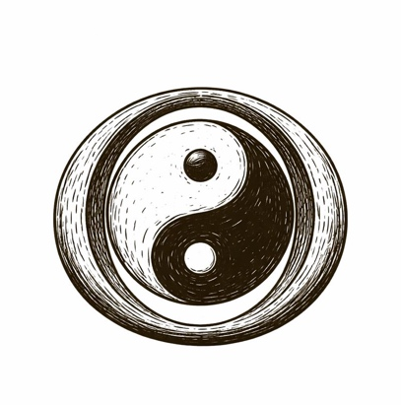

In the beginning, the Chinese storytellers say, there was only an egg.
Not a fragile breakfast thing—an absolute one: a sealed whole where sky and earth, light and dark, order and chaos were mixed into a single, undifferentiated sleep.
Then Pangu woke.
He did not discover a world. He made one—by splitting it. With every breath, the light rose and the heavy sank; with every day, the distance grew. The universe became navigable only because someone did the violent, careful work of separation: yin from yang, above from below, what-is from what-could-be.
Diagnosis is noticing the egg is cracking.
Design is deciding where the seam should go—and

what kind of world you’ll be responsible for once it opens.

